React port 3000 communicats with spring boot port 8080 !

We choose to make them communicate on load !

USE LOCAL STORAGE TO STORE DATA !

LocalStorage.getItem(),

LocalStorage.setItem(),

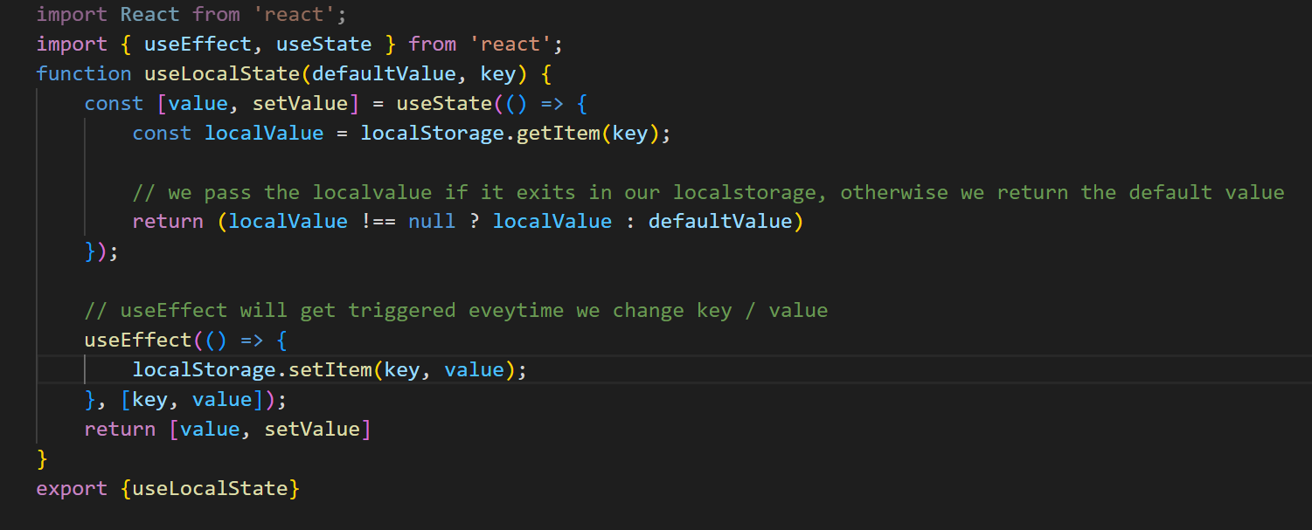

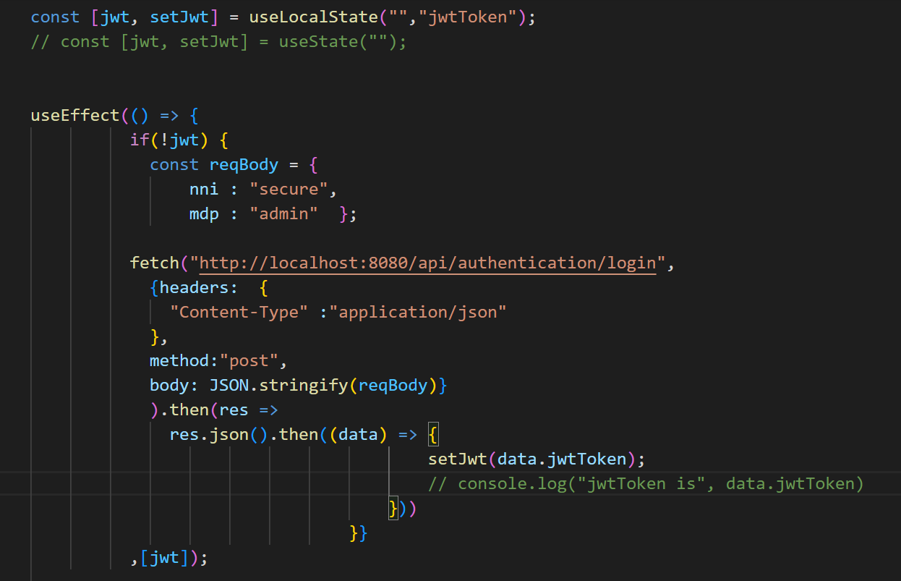

React routes !

